CI7330 – Data Analytics and Visualisation

Assignment 1

Data Analysis Report

Dataset Overview:

The analysis is based on the provided dataset Employeesatisfaction.csv, containing survey responses from 1,470 employees.
Key Variables:
- Age: Employee age in years (range: 18–60)
- distance: Travel distance to work in miles (range: 1–29)
- education: Education level (1: No formal qualifications to 5: Post degree qualification)
- Sex: Male or Female
- Jobsatisfaction: Job satisfaction rating (1: Not satisfied at all to 4: Satisfied)
- incomeGBP: Monthly take home salary in £
- environment: Satisfaction with working environment
- no_comps: number of companies worked at
- Salary_incr: Percentage of last Salary increase
- totalwk: Total years working
- company_yrs: Years worked at current company

Question 1 : Describe the age profile of the workforce.

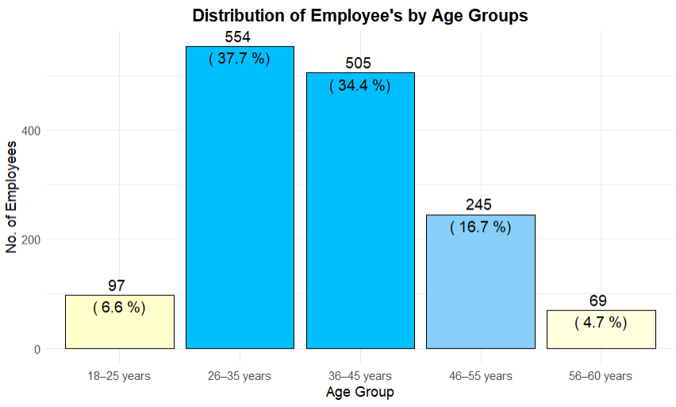

Insights:
- As seen in the visual the company's employees are mostly in their mid-career years. The 2 age groups make up 72% of the workforce, that's 554 people (37.7%) in the 26–35 age group and 505 (34.4%) in the 36–45 group.
- The Younger employees (aged 18–25) are the smallest group, with only 97 people (6.6% of the workforce).
- Older employees (aged 46–60) are larger than the youngest group but still much smaller than the Middle Ages, there are 245 people aged 46–55 (16.7%) and 69 aged 56–60 (4.7%). Together, everyone aged 46 and over makes up 21.4%.
- This means the company has a strong workforce in their 30s and early 40s, which can bring stability and knowledge. However, there are far fewer young or near-retirement workers, so the workforce has limited variety across different generations.

Question 2: Describe the average monthly incomes of employees.

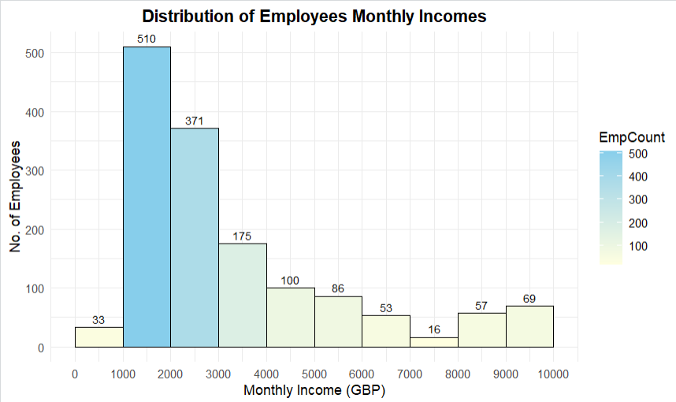

Insights :
- From the chart we see the most employees earn in the £1000–2000 monthly salary with 510 employees (i.e. 1/3 of the workforce) earns in this range. From this we can say that the monthly incomes are strongly right-skewed.
- The next highest is £2000–3000 (371 employees), followed by a sharp drop to £3000–4000 (175).
- As the monthly salary increases further we see steady decline thereafter: 100 (£4000–5000), 86 (£5000–6000), 53 (£6000–7000), 16 (£7000–8000), 57 (£8000–9000), and 69 (£9000–10000).
- There are very few employees (33) earn below £1000, and the long right tail shows a small number of high earners above £8000.
- A long tail of higher earners exists, but most staff receive modest pay, reflecting considerable income variation driven by a smaller high-paid group.

Question 3 : Describe and summarise the average distances employees travel to work.

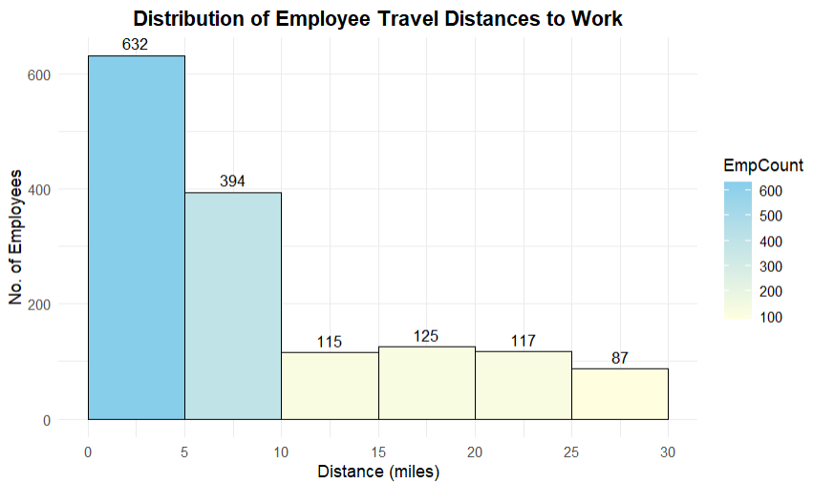

Insights:

- Employee travel distances are strongly right-skewed, with nearly 70% commuting under 10 miles.
- We can see that majority commute very short distances: 632 employees (over 43%) in the 0–5-mile bin and 394 employees (about 27 %) in the 5–10-mile bin.
- As the travel distance increases from 10 miles we notice a sharp drop in employee’s: 115 (10–15), 125 (15–20), 117 (20–25), and only 87 (25–30).
- There are no employees who commute beyond 30 miles.
- From the visual we get to understand that majority of employee’s prefer less commute time to maintain punctuality and have more time for the rest of the day.

Question 4 : Describe and summarise employees’ educational backgrounds.

lvl | Education Level | Employee count | Percentage (%)
1 | No formal qualifications | 170 | 11.6
2 | Minimum 5 GCSEs | 282 | 19.2
3 | A level or equivalent | 572 | 38.9
4 | HE degree | 398 | 27.1
5 | Post degree qualification | 48 | 3.3
Total |  | 1470 | 100.0

Insights:
- The largest group by far is level 3 ("A level or equivalent") with 572 employees (38.9% of the total workforce).
- Level 4 ("HE degree") follows closely with 398 employees (27.1%).
- Lower qualifications are less common: level 2 ("Minimum 5 GCSEs") at 282 (19.2%), level 1 ("No formal qualifications") at 170 (11.6%).
- Advanced qualifications are rare: level 5 ("Post degree qualification") at only 48 (3.3%).
- Educational backgrounds mainly focus on A-level equivalents (38.9%) and HE degrees (27.1%), together comprising two-thirds of workforce. Lower qualifications make up 30.8%, while post-degree levels are uncommon (3.3%). This indicates a solidly qualified workforce geared toward skilled roles, though lacking extensive advanced specialisation.

Question 5: Explore incomes by age

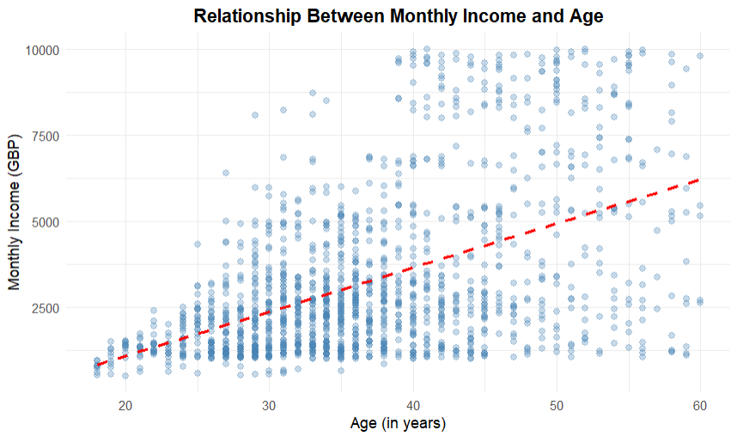
Insights :
- There is a clear upward trend: incomes generally increase with age, as points shift higher from the 20s (mostly below £5000) to the 50s-60s (many above £6000-£8000).
- The densest cluster is in ages 30-50 with incomes £2500-£5000, forming a thick band where most employees fall.
- The red trend line slopes positively, starting around £2000 at age 20 and rising to £6000 by age 60.
- As seen from the visual the scatter exists at all age older employees show the widest range with some earning low and others reaching £10,000.
- Pearson r = 0.50 quantifies this positive association, concluding that age contributes to higher earnings through experience, though other factors clearly influence outcomes.
- Overall, we see that age helps increase income, but it's not a strong or perfect link.
Question 6: Explore incomes between the sexes

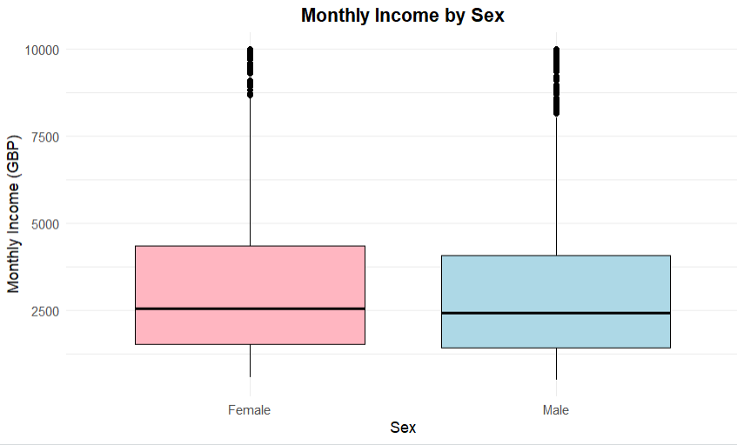

Key observations from the plot:
- Medians are almost identical, with females slightly higher (just above £2500) than males (just below).
- Box heights are very similar, indicating comparable spread in the middle 50% of incomes.
- Whiskers extend to similar upper and lower values, showing no major difference in overall range.
- There are few high-income outliers exist in both groups, reaching up to £10,000.

t-test to check difference in average incomes between the sexes:

data: incomeGBP by Sex
t = 1.2223, df = 1261.5, p-value = 0.2218

sample estimates:
mean in group Female | mean in group Male
3343.283 | 3190.254

Insights:
- The box plot displays remarkably similar income distributions between females and males, with nearly overlapping medians, boxes, and whiskers, plus shared high outliers. This visual equivalence suggests equitable pay.
- The t-test (p = 0.222 > 0.05) confirms no significant difference in means, concluding that gender does not drive income gaps here compensation appears fair across sexes.

Question 7: Explore incomes by education

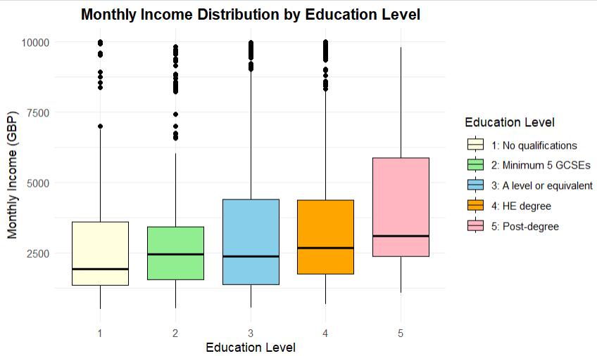
Insights:

The box plot clearly shows how monthly incomes vary across the five education levels, with distinct colours and a legend making each group easy to identify.
Incomes increase noticeably with higher qualifications.
- The median starts lowest at level 1 (around £2,000–£2,500) and rises steadily, reaching its highest at level 5 (around £5,000–£6,000).
- Boxes and whiskers get taller and longer from level 3 onward, especially at levels 4 and 5, meaning incomes spread out more widely among degree holders.
- High-income outliers are scattered in all groups but found more in levels 4 (HE degree) and 5 (post-degree).
- This shows that greater earning potential and variability is seen in degree holders.

Tests to check the significant difference in average incomes between the education groups:

- We performed ANOVA test for average monthly incomes differ significantly across the five education groups.
- From the image we see the result was F(4, 1465) = 3.893, p = 0.00377 (< 0.05), indicating statistically significant differences in mean incomes between education levels

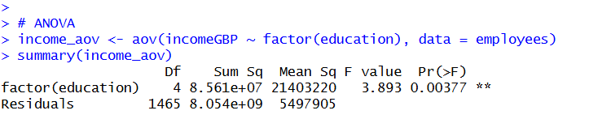

- Since ANOVA confirmed differences but does not specify where, so performed the post-hoc Tukey HSD test for further analysis.
- The post-hoc Tukey HSD test helps us to find exactly where the differences are present.
- Below is the screenshot of the test conducted along with the output.

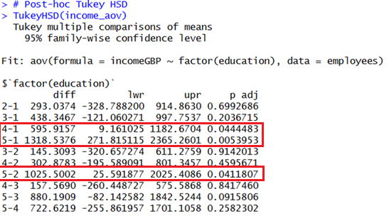

From the post-hoc Tukey test results we get to know there are 3 groups which have average income differences (i.e. adjusted p < 0.05) which are highlighted in the red box :
- Level 1 (No qualifications) to Level 4 (HE degree)
- Level 1 (No qualifications) and Level 5 (Post-degree)
- Level 2 (Minimum 5 GCSEs) and Level 5 (Post-degree)
Other than these 3 groups we didn’t find any major differences in the average incomes.

Question 8: Explore job satisfaction by sex and educational background

- Job Satisfaction by Sex

Job Satisfaction | Female | Male
Not satisfied | 119 | 170
Neutral | 118 | 162
Satisfied | 181 | 261
Very Satisfied | 170 | 289
Total | 588 | 882

Job Satisfaction | Female (%) | Male (%)
Not satisfied | 20.2 | 19.3
Neutral | 20.1 | 18.4
Satisfied | 30.8 | 29.6
Very Satisfied | 28.9 | 32.8
Total | 100.0 | 100.0

Key observations from the table:

- We get to know that both groups have very similar patterns: around 20% "Not satisfied", 19-20% "Neutral", 30% "Satisfied", and 29–33% "Very satisfied".
- Females: 20.2% Not satisfied, 20.1% Neutral, 30.8% Satisfied, 28.9% Very satisfied.
- Males: 19.3% Not satisfied, 18.4% Neutral, 29.6% Satisfied, 32.8% Very satisfied.
- Overall, about 60% in both groups rate Satisfied/Very satisfied.
Statistical Test and Findings:
From R output χ² = 2.55, df = 3, p = 0.467 ( > 0.05) confirms no significant association between sex and job satisfaction.
Insights:
Job satisfaction levels are essentially the same for males and females. Gender does not appear to influence how employees feel about their jobs, suggesting any satisfaction issues are shared across the workforce rather than gender-specific.
As there around 20% of employees in males and females who are not satisfied in their work, the employer should look into this and check what other factors like working hours, environment etc. are affecting the employees and should take measures to improve it.

- Job Satisfaction by Education
Job Satisfaction | No formal qualifications | Minimum 5 GCSEs | A level or equivalent | HE degree | Post degree
Not satisfied | 32 | 52 | 118 | 74 | 13
Neutral | 26 | 54 | 128 | 67 | 5
Satisfied | 56 | 83 | 161 | 127 | 15
Very Satisfied | 56 | 93 | 165 | 130 | 15
Total | 170 | 282 | 572 | 398 | 48

Job Satisfaction | No formal qualifications | Minimum 5 GCSEs | A level or equivalent | HE degree | Post degree
Not satisfied | 18.8 | 18.4 | 20.6 | 18.6 | 27.1
Neutral | 15.3 | 19.1 | 22.4 | 16.8 | 10.4
Satisfied | 32.9 | 29.4 | 28.1 | 31.9 | 31.2
Very Satisfied | 32.9 | 33.0 | 28.8 | 32.7 | 31.2
Total | 100.0 | 100.0 | 100.0 | 100.0 | 100.0

Key observations from the tables:

- Across all education levels, ratings are balanced: roughly 19–27% "Not satisfied", 18–22% "Neutral", 28–32% "Satisfied", and 29–33% "Very satisfied".
- No education group is very different from the others. Even people with post-degree qualifications have similar ratings, for example, 27.1% "Not satisfied" but 31.2% "Very satisfied".
Statistical Test and Findings:
From R output: χ² = 13.03, df = 12, p = 0.367 (> 0.05). No significant difference; satisfaction is independent of education.
Insights:
The results show no real difference in job satisfaction between employees with different levels of education. For the employer, this means everyone feels about the same regarding their job, no matter what qualifications they have. So, if the company wants to make staff happier, it should look at things that affect everyone like working conditions, management style, or company culture instead of focusing on particular education groups.
Conclusion:
Job satisfaction is consistent across both sex and education. There are no significant differences in how employees rate their jobs based on gender or qualifications. This means the company can focus on things that affect everyone equally like work environment, working hours, management to improve satisfaction, rather than targeting specific groups.

Rstudio code for the assignment:

getwd()

setwd("D:/MSc Assignments/DataVisual/Assign1")

library(ggplot2)
employees <- read.csv("Employeesatisfaction.csv")

# ------------------------------------------------------------Question1-------------------------------------------------------

employees$Age_Group <- cut(employees$Age, breaks = c(17, 25, 35, 45, 55, 61),
labels = c("18–25 years", "26–35 years", "36–45 years", "46–55 years", "56–60 years"),
right = FALSE)
age_summary <- as.data.frame(table(employees$Age_Group))
names(age_summary) <- c("Age_Group", "Count")
age_summary$Percentage <- round(age_summary$Count / sum(age_summary$Count) * 100, 1)

ggplot(age_summary, aes(x = Age_Group, y = Count, fill = Age_Group)) + geom_col(colour = "black") +
geom_text(aes(label = paste(Count, "\n(", Percentage, "%)")), size = 3.5) +
scale_fill_manual(values = c("#ffffcc", "deepskyblue","#00bfff", "#87cefa", "lightyellow")) +
labs(title = "Distribution of Employee's by Age Groups", x = "Age Group", y = "No. of Employees") +
theme_minimal() + theme(plot.title = element_text(hjust = 0.5, face = "bold"), legend.position = "none")

# ------------------------------------------------------------Question2-------------------------------------------------------

ggplot(employees, aes(x = incomeGBP, fill = ..count..)) +
geom_histogram(breaks = seq(0, 10000, by = 1000), colour = "black") +
geom_text(stat = "bin", breaks = seq(0, 10000, by = 1000), aes(label = ..count..), vjust = -0.5, size = 3) + scale_fill_gradient(low = "lightyellow", high = "skyblue", name = "EmpCount") +
scale_x_continuous(breaks = seq(0, 10000, by = 1000)) +
labs(title = "Distribution of Employees Monthly Incomes", x = "Monthly Income (GBP)", y = "No. of Employees") + theme_minimal() + theme(plot.title = element_text(hjust = 0.5, face = "bold"))

# ------------------------------------------------------------Question3-------------------------------------------------------

ggplot(employees, aes(x = distance, fill = ..count..)) +
geom_histogram(breaks = seq(0, 30, by = 5), colour = "black") +
geom_text(stat = "bin", breaks = seq(0, 30, by = 5), aes(label = ..count..), vjust = -0.5, size = 3.5) +
scale_fill_gradient(low = "lightyellow", high = "skyblue", name = "EmpCount") +
scale_x_continuous(breaks = seq(0, 30, by = 5)) +
labs(title = "Distribution of Employee Travel Distances to Work", x = "Distance (miles)", y = "No. of Employees") +
theme_minimal() + theme(plot.title = element_text(hjust = 0.5, face = "bold"))

# ------------------------------------------------------------Question4-------------------------------------------------------

counts <- table(employees$education)
percent <- round(prop.table(counts) * 100, 1)
edu_summary <- data.frame( Level = 1:5, Description = c("No formal qualifications", "Minimum 5 GCSEs", "A level or equivalent", "HE degree", "Post degree qualification"), Count = as.vector(counts), "Percentage (%)" = as.vector(percent))
edu_summary <- rbind(edu_summary, c("Total", "", sum(edu_summary$Count), 100.0))
print(edu_summary, row.names = FALSE)

# ------------------------------------------------------------Question5-------------------------------------------------------

ggplot(employees, aes(x = Age, y = incomeGBP)) +
geom_point(alpha = 0.3, colour = "steelblue", size = 2) +
geom_smooth(method = "lm", colour = "red", se = FALSE, linetype = "dashed", size = 1.2) +
labs(title = "Relationship Between Monthly Income and Age",
x = "Age (in years)", y = "Monthly Income (GBP)") +
theme_minimal() + theme(plot.title = element_text(hjust = 0.5, face = "bold"))

# ------------------------------------------------------------Question6-------------------------------------------------------

ggplot(employees, aes(x = Sex, y = incomeGBP, fill = Sex)) +
geom_boxplot(colour = "black") +
scale_fill_manual(values = c("Female" = "lightpink", "Male" = "lightblue")) +
labs(title = "Monthly Income by Sex", x = "Sex", y = "Monthly Income (GBP)") +
theme_minimal() + theme(plot.title = element_text(hjust = 0.5, face = "bold"),
legend.position = "none")
t.test(incomeGBP ~ Sex, data = employees)

# ------------------------------------------------------------Question7-----------------------------------------------------

employees$Edu_Level <- factor(employees$education, levels = 1:5, labels = c("1: No qualifications",
"2: Minimum 5 GCSEs", "3: A level or equivalent", "4: HE degree", "5: Post-degree"))
ggplot(employees, aes(x = factor(education), y = incomeGBP, fill = Edu_Level)) +
geom_boxplot(colour = "black") +
scale_fill_manual(values = c("lightyellow", "lightgreen", "skyblue", "orange", "lightpink"),
name = "Education Level") + labs(title = "Monthly Income Distribution by Education Level",
x = "Education Level", y = "Monthly Income (GBP)") +
theme_minimal() + theme(plot.title = element_text(hjust = 0.5, face = "bold"), legend.position = "right")
# ANOVA
income_aov <- aov(incomeGBP ~ factor(education), data = employees)
summary(income_aov)

# Post-hoc Tukey HSD
TukeyHSD(income_aov)

# ------------------------------------------------------------Question8-------------------------------------------------------

# (i) Job Satisfaction by Sex
tab_sex <- table(employees$Jobsatisfaction, employees$Sex)
rownames(tab_sex) <- c("Not satisfied", "Neutral", "Satisfied", "Very Satisfied")
print(tab_sex)
prop_sex <- round(prop.table(tab_sex, margin = 2) * 100, 1)
cat("\nColumn Percentages (%):\n")
print(prop_sex)
cat("\nChi-square Test for Sex:\n")
print(chisq.test(tab_sex))

# (ii) Job Satisfaction by Education
tab_edu <- table(employees$Jobsatisfaction, employees$education)
rownames(tab_edu) <- c("Not satisfied", "Neutral", "Satisfied", "Very Satisfied")
colnames(tab_edu) <- c("No formal qualifications", "Minimum 5 GCSEs", "A level or equivalent",
"HE degree", "Post degree qualification")
print(tab_edu)
prop_edu <- round(prop.table(tab_edu, margin = 2) * 100, 1)
cat("\nColumn Percentages (%):\n")
print(prop_edu)
cat("\nChi-square Test for Education:\n")
print(chisq.test(tab_edu))

Use of Generative Artificial Intelligence

- I did not use any generative artificial intelligence tools in the preparation or completion of this assignment.
- All analysis, visualisations, code, interpretations, and written content are my own original work, produced independently using RStudio and the provided dataset.

